**Improving Revenue Generation**

**on**

**Catch the Pink Flamingo**

**by Sarsiz Chauhan**

**Data Exploration : Data Set Overview**

|  |  |
| --- | --- |
|  |  |
|  |  |
|  |  |
|  |  |
|  |  |
|  |  |
|  |  |
|  |  |

|  |  |
| --- | --- |
|  |  |
|  |  |
|  |  |
|  |  |

The table below lists each of the files available for analysis with a short description of what is found in each one.

|  |  |  |  |  |
| --- | --- | --- | --- | --- |
| **FILE NAME** | **ERD TABLE** | **DESCRIPTION** | **FIELDS** | |
| ad-clicks.csv | AdClicks | A line is added to this file when a player clicks on an advertisement in the Flamingo app. |  | |
| **timestamp** | when the click occured |
| **txId** | unique id for the click (within ad-clicks.log) for the click |
| **userSessionid** | id of user session for user who made click |
| **teamid** | current team id of user who made the click |
| **userid** | user id of user who made the click |
| **adId** | id of the ad licked on |
| **adCategory** | category/type of ad clicked on |
|  | |
| buy-clicks.csv | InAppPurchases | A line is added when a player makes an in-app purchase on Flamingo app | **timestamp txId userSessionid**  **team**  **userid buyId price** | when the click occured  unique id for the click (within ad-clicks.log) id of user session for user who made click  current team id of user who made the purchase  user id of user who made the click id of the item purchased  price of the item purchased |
| users.csv | User | File contains a line for each user playing the game. | **timestamp**  **userId nick** | when the click occured  user id of user who made the click nickname chosen by the user |

|  |  |  |  |  |
| --- | --- | --- | --- | --- |
|  |  |  | **twitter dob country** | twitter handle of the user date of birth of the user  2-letter country code where the user lives |
|  |  |  | **teamId** | id of the team |
|  |  |  | **name** | name of the team |
| team.csv | Team | File contains a line for each team terminated in the game. | **teamCreationTime**  **teamEndTime** | timestamp when team was created  timestamp when last member of the team |
|  |  |  | **strength** | measure of team strength roughly corresponding to the success of a time |
|  |  |  | **currentLevel** | current level of a team |
| team-assignments.csv | TeamAssignment | A line is added each time a user joins a team.  A user can be in at most a single team at a time. | **timestamp team userId**  **assignmentId** | when the user joined the team id of the teamuser  id of the user  unique id for this assignment |
|  |  |  | **timestamp** | when the click occured |
|  |  |  | **eventId** | unique id for the event |
| level-events.csv | LevelEvent | A line is added each time a team starts or finishes a level in the game. | **teamid** | id of the team |
|  |  |  | **teamLevel** | level started or completed |
|  |  |  | **eventType** | type of event (start or end) |

|  |  |
| --- | --- |
|  |  |
|  |  |
|  |  |
|  |  |

|  |  |
| --- | --- |
|  |  |
|  |  |
|  |  |
|  |  |
|  |  |
|  |  |
|  |  |

|  |  |
| --- | --- |
|  |  |
|  |  |
|  |  |
|  |  |
|  |  |

|  |  |
| --- | --- |
|  |  |
|  |  |
|  |  |
|  |  |
|  |  |
|  |  |

|  |  |  |  |  |
| --- | --- | --- | --- | --- |
|  |  |  | **timestamp** | when the click occured |
|  |  |  | **userSessionid** | unique id for the session |
|  |  | Each line describes a user session, which | **userId** | current user’s ID |
| user.session.csv | User_Sessions | denotes when a user starts and stops playing the game.  When a team goes to next game level, the | **teamid**  **assignmentId** | current user’s team  team assignment id for the user to the team |
|  |  | session is ended for each user in the team and a new one is started. | **sessionType** | whether the event is the start or end of a session |
|  |  |  | **teamLevel** | level of team during the session |
|  |  |  | **platformType** | type of platform of the user during the session |
|  |  |  | **timestamp** | when the click occured |
|  |  |  | **clickId** | unique id for the click |
|  |  |  | **userId** | click user’s ID |
|  |  |  | **userSessionId** | id of the session of user when click occurs |
| game-clicks.csv | GameClicks | A line is added each time a user performs a click in the game. | **idHit** | if click hits flamingo (val=1) or missed (val=0) |
|  |  |  | **teamId** | id of the team of the user |
|  |  |  | **teamId** | id of the team of user |
|  |  |  | **teamLevel** | level of team during the session |

|  |  |
| --- | --- |
|  |  |
|  |  |
|  |  |
|  |  |
|  |  |
|  |  |
|  |  |
|  |  |
|  |  |

|  |  |
| --- | --- |
|  |  |
|  |  |
|  |  |
|  |  |
|  |  |
|  |  |
|  |  |
|  |  |
|  |  |

**Aggregation**

|  |  |  |
| --- | --- | --- |
| Amount spent buying items | source="buy-clicks.csv" | stats sum(price) | 21407.0 |
| Number of unique items available to be purchased | source="buy-clicks.csv" | stats dc(buyId) | 6 |

# Histograms

1. A histogram showing how many times each item is purchased:

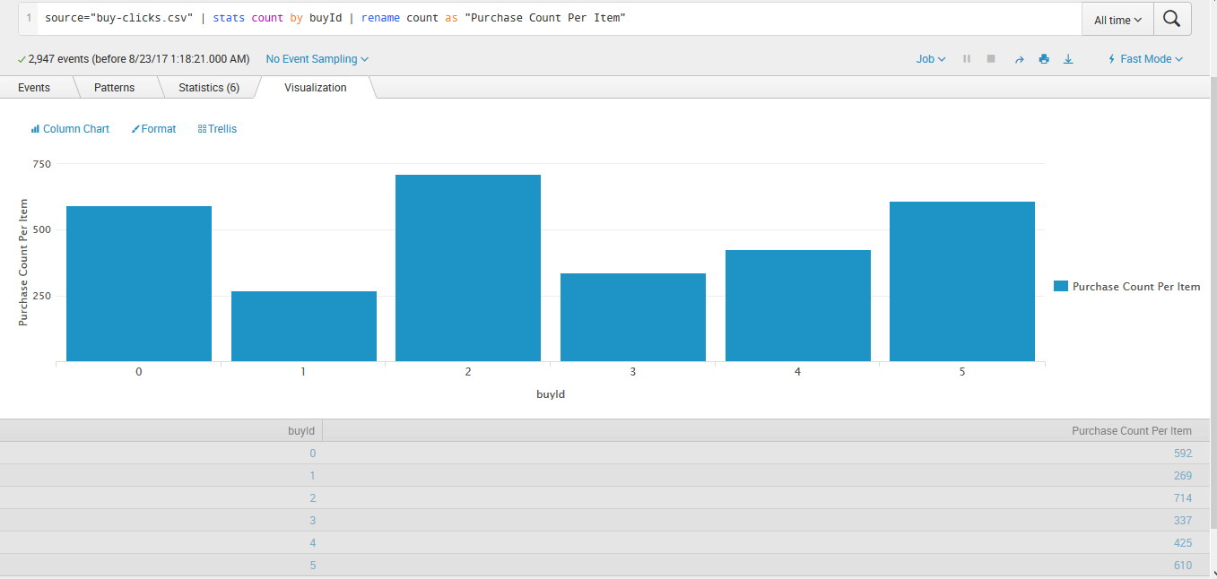

1. A histogram showing how much money was made from each item:

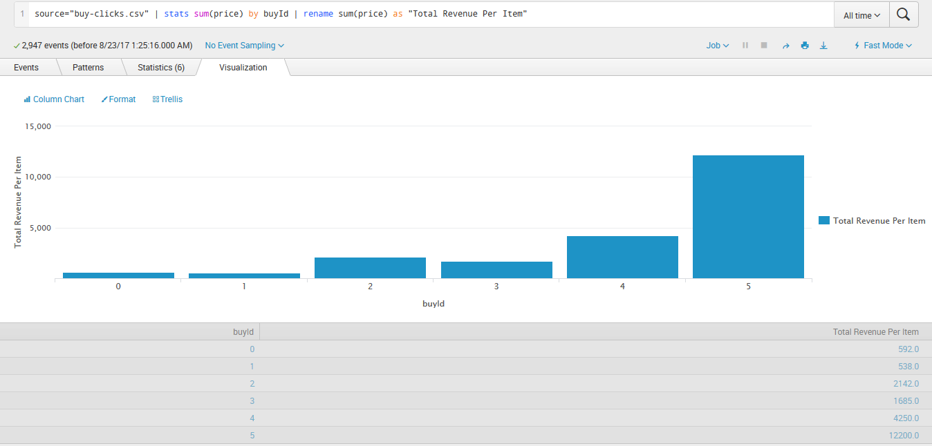

# Filtering

1. A histogram showing total amount of money spent by the top ten users (ranked by how much money they spent).:

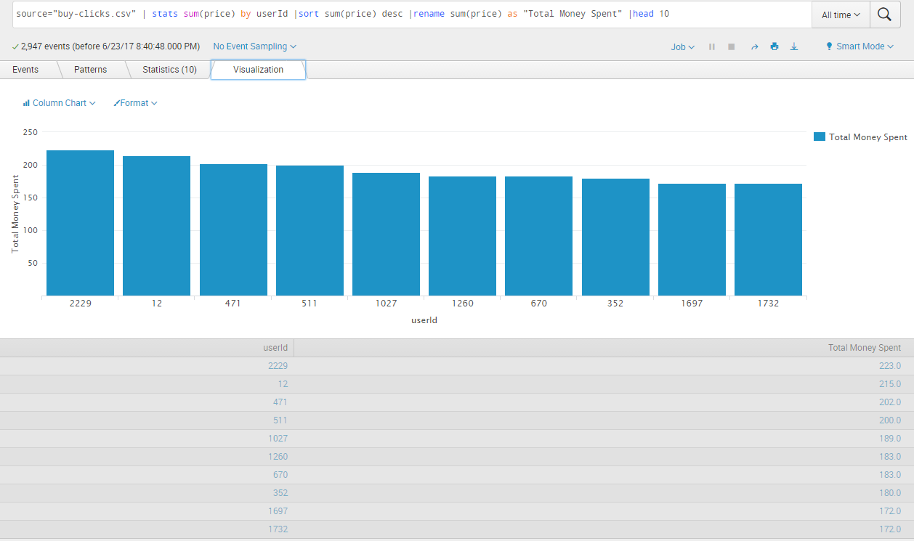

1. The following table shows the user id, platform, and hit-ratio percentage for the top three buying users:

